Purpose

The goal of this assignment is to understand and demonstrate the function and abilities of the digital servo’s analog and digital shaft sensors and how they interface with the design environment of the digital servo.

Equipment

- 33-120 Digital Unit
- D/A – A/D converters
- DC power source
- Analog Shaft Position Sensor
- Digital Shaft Position Sensor
- Input/output potentiometers (POT)
- Computer

Results/Analysis

3.1: Using the A/D input and the input Potentiometer:

The input potentiometer generates a voltage based on the position of a slider along a resistor that corresponds to the position of the shaft. This voltage can be used to determine the position of the shaft. In order to make this information more usable, we use the A/D converter on the digital unit feed the data to the computer for observation.

Once the system is set up correctly, the input POT can be adjusted from 0º to -160º on the digital unit. The corresponding values were observed from the computer as shown in the Potentiometer Input plots observed from the computer:
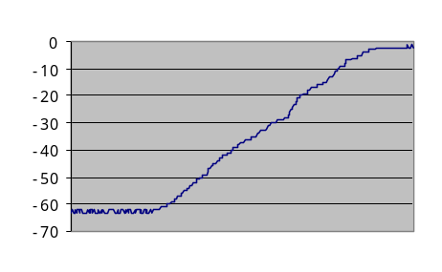
Potentiometer Input: 0⁰ -> -90⁰

These plots illustrate a phase (position shift) corresponding to the adjustment made on the input potentiometer [90º, 70º, 110º].

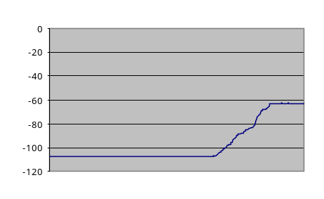
Potentiometer Input: -90º -> -160º
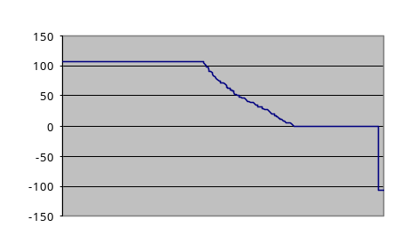
Potentiometer Input: 0º -> -110

3.2: Using the A/D input and the output shaft POT w/ motor rotating:

The output potentiometer works in the same way as the input potentiometer accept the output POT fixed to the output shaft. Using this POT, the position of the shaft can be observed while moving and used to determine the shaft speed via the A/D converter and the computer. In this way, the computer can control the motor drive using a D/A converter as well as monitor the output from the shaft.

To control the motor drive, a value is varied from 127 to –127 on the computer, converted via the D/A converter, and subsequently sent to the motor. The graphs below display the results observed on the computer display corresponding to the specified motor drive. Changing the sign of the input reversed the direction of the motor, while a higher absolute value of the input resulted in a higher velocity and visa-versa:

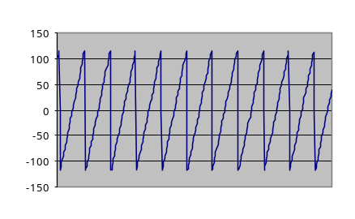
Motor Drive = - 123
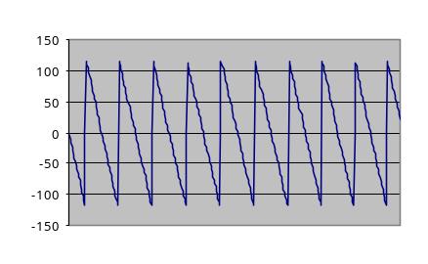
Motor Drive = 123
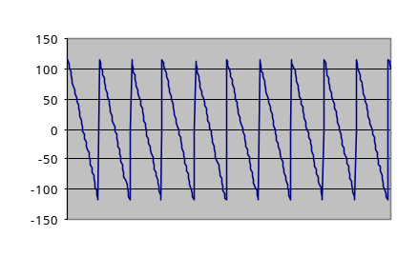
Motor Drive = 96
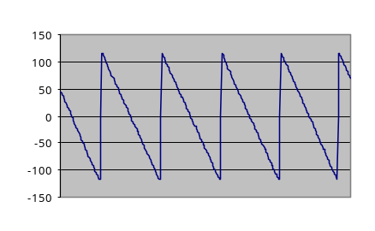
Motor Drive = 45
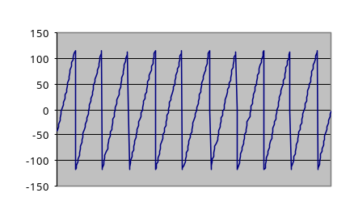
Motor Drive = - 96
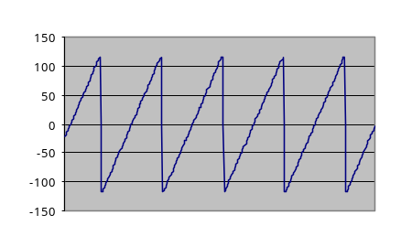
Motor Drive = - 49

3.3: Using the absolute encoder w/ Gray code:

To digitally sense the position/direction of the shaft the digital servo uses two methods. The first method examined is the absolute encoder, which is setup on the mechanical unit as a simple positional servo using the error channel on the digital unit. This wheel has binary values assigned via ‘holes’ on tracks around the wheel that correspond to each position of the shaft. For this unit there are 6 tracks allowing 2⁶ positions (64 levels) to be sensed. The code is sensed by an infa-red send/receive system where all six tracks can be sampled at any given moment in time. If the infa-red signal is received, then the resulting value for that bit is 1 (otherwise 0).

Because all 6 sensors must function correctly for an accurate position code to be read, there is the possibility of error in operation causing 1+ of these bits to be mis-read. If a standard, incremental code was used to correspond to sequential positions, the error from 1 mis-read bit could be very high during steps in which more than one bit changes (i.e. 011111 -> 100000).

To avoid this possibility, the Gray code used by this system instead of an incremental code (000000 – 111111). The Gray code has only one bit change per phase step limiting the maximum error to 1 which is much more tolerable than the possible errors resulting from incremental bit encoding.

To observe the functionality as well as compare the accuracy of this system, both signals (potentiometer and absolute encoder) are displayed on the computer’s output as the shaft position is varied at different frequencies (via the mechanical unit) and amplitudes (via the digital unit).
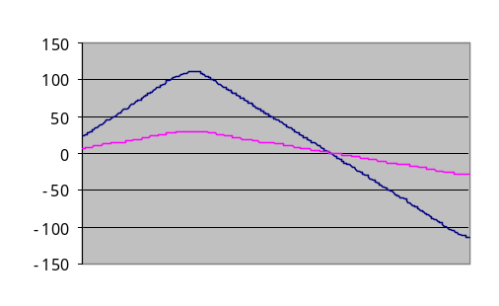
MIN freq – MAX Amp

Examining the graphs taken from the computer display, the effects of various combinations of frequency and amplitude values is illustrated. Note that at MIN amplitude there was obviously no transient signal. These graphs show that the absolute encoder exactly follows the period of the potentiometer thus proving the validity of the absolute encoder.

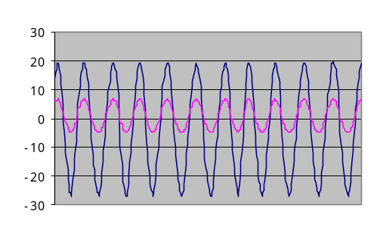
MAX freq – MAX Amp
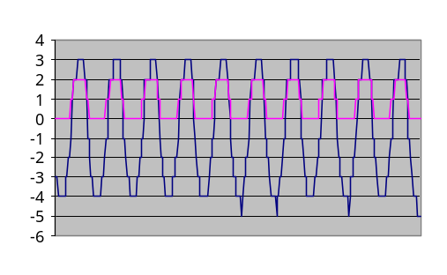
MAX Freq – LOW Amp

3.4: Using an incremental encoder w/ a 2-phase track:

The second method the digital unit uses to sense the position/direction of the shaft is an incremental encoder. This system uses a similar set-up to the absolute encoder in that a wheel encoded with tracks is read via infa-red sensors. However, this wheel has only two tracks with one track oriented to allow a counter to track the progress of the wheel and another track with it’s pattern set at 90º to the first to give information about the direction of the rotation. The combination of these two signals allows the computer to increment or decrement the counter accordingly thus representing the shaft’s position. For higher resolution, the incremental encoder wheel is moving at a much faster rate than the shaft proportionally.

Because of the “counter-method” of position tracking, higher frequency and/or larger input situations will cause the encoder to lose synchronization. This is caused by the inability of the computer and/or infa-red sensors to ‘keep’ up with the rate of the wheel. This is not unexpected; as with most electro-mechanical systems the performance is degraded when the system is operated at its limits. At these limits, transmission of and operation on data as well as mechanical-electrical timings are stressed causing errors.

These errors will never be corrected as they would with the absolute encoder without a mechanism in place to do so. The mechanism used here is a sync-pulse used every rotation to ensure proper operation. Using this method, errors can only propagate the duration of one rotation thus limiting the accumulated error over time.

To examine this method of measurement, we performed the same test used with the absolute encoder. Amplitude and frequency were adjusted to test the tracking, however it must be taken into account that the computer speed will affect the synchronization between the potentiometer and the incremental encoder signals.

Unfortunately no graphs are available for this portion of the practical, but our observations were as follows:

- At HIGH frequencies, NORM amplitude -- the amplitude of the two signals is off by a constant factor
- At HIGH frequencies, LOW amplitude – the error in amplitude between the two signals occurs more slowly over time
- At LOW frequencies, HIGH amplitude – the error in the amplitude between the two signals occurs almost instantaneously
- Due to the sync-pulse, the period of the two signals is synchronized under all conditions

3.5: Using the incremental encoder to measure shaft speed and direction:

The experiment above demonstrated how the incremental encoder can be used to acquire information about the shaft’s speed and direction. Using this information the computer can calculate the speed of the shaft by sampling the number of increments over a period of time and determine the speed based on the distance traveled per increment. Furthermore the computer will use the directional information obtained by the incremental encoder to determine the direction in which the wheel is rotating.

To understand the abilities of the incremental encoder to function as a “digital tachometer” the values of the encoder as well as the tachometer were displayed via the computer simultaneously. We observed a negative offset of the encoders speed in relation to the tachometer. This offset increases as the motor drive (speed) was increased. A ripple was also noticed in the encoder signal. These affects are a result of the limitations (imperfections) of the digital data. The tachometer uses an analog set-up (output potentiometer) that is not affected by data acquisition errors discussed in the previous practical or by limitations in the computer (A/D converter) speed (sampling rate). Because these errors are directly related to the speed of operation, their affect will also be directly related.

Conclusions

The data related to the state of the system is vitally important to the design and operation of a control system. Therefore it is equally vital to understand the acquisition and limitations of this data when designing a control system. This lab has allowed us to understand and quantify the various methods used to collect data relating to the state of the digital servo system for use in our future design of a digital servo control system by giving us an understanding of how it is acquired and what considerations must be taken into account when using this data. The knowledge gained from these experiments will allow us to more accurately and effectively characterize our design and compensate for its limitations.

References

There were no references used for this lab other than the lab book and Hao Xu.

Questions

3.1: Using the A/D input and the input Potentiometer:

- The potentiometer produces a voltage depending on the angular position and feeds the information to a computer that can determine the rate of change of this voltage, which is proportional to the speed of the shaft.

Advantages:
Cheap
High output voltage can be obtained
Measurement easier
Accuracy of measurement higher

Disadvantages:
Degrades with age
Friction due to the sliding motion loads the motor system
Movement will be bouncy due to slider/resistor contact

3.2: Using the A/D input and the output shaft POT w/ motor rotating:

- The potentiometer can be used for angle sensing by being mounted to the back of the output shaft with the slider connected to it. Therefore, voltage will be proportional to the angular displacement of the output shaft.
- The value of the signal for angular position ranges from 120 to –120 for a total span of 240. Since the complete spectrum of movement of the shaft should be 360º, the relationship between the shaft position and the output voltage seems to be approximately 1.5º: 1 from our experiments. In theory an offset value is not unlikely since the shaft position is determined by the ratio of voltages multiplied by the total length (angular span) of the potentiometer.
- The waveform is a “saw-tooth” waveform. This is because the shaft position repeats every 360º therefore the signal on the graph must return to the bottom once the shaft has completed 1 cycle.

3.3: Using the absolute encoder w/ Gray code:

1. A pattern of tracks, each representing 1 bit on the Gray Code, is printed on a disc, which is mounted on an output shaft. There are six tracks, and each sector of the track represents one of the 64 positions on the output shaft (2^6=64).
In this practical, the tracks are read off using infra-red sensors that give the angular position of the motor. The output of the potentiometer and the encoder disc are shown on the computer.

3.4: Using an incremental encoder w/ a 2-phase track:

1. The encoder uses a disc with two tracks printed on it attached to the motor shaft. The infra-red sensors reads a series of pulses representing change in angular position. A second track gives information about the direction of rotation. These two signals are sent to a computer to represent the shaft position. The second disc is mounted on a shaft rotating faster than the output shaft to obtain a good resolution.

3.5: Using the incremental encoder to measure shaft speed and direction:

- The system block diagram is as follows:

D/A CONV.

MOTOR

TACHO
METER

A/D CONV.

ENCODER

COMPUTER

DISPLAY

MOTOR: This device controls the shaft speed via variances in applied voltage (motor drive). Via the D/A converter the computer can make adjustments to the speed of the motor based on the output of the tachometer and/or encoder.

TACHOMETER: This analog device works on a potentiometer to determine then current speed of the shaft.

ENCODER: This device transmits the directions and advances of the shaft in set increments to the computer for use in calculating speed/position. The detailed operation of this device is described in sections 3.4 and 3.5 above.

D/A – A/D CONVERTER: Used to converter analog TACHOMETER signals to digital for use by the computer and digital computer signals to analog for motor drive.

COMPUTER: Measures the number of units (increments) traveled over a period of time to determine the current speed of the shaft. This signal is displayed on the computer DISPLAY along with the output of the TACHOMETER once it has been converted to digital form.

DISPLAY: This is the media used by the computer to output the results from the TACHOMETER and the calculations based on the ENCODER.

